**Name: Divesh Oree**

**Student Number: N01060689**

**Course Name: Hardware Production Tech (CENG 317)**

**Section Number: ONA**

**Date: 2016-10-11**

**Week 5: Mechanical Assembly Milestone**

In this week 5, I have managed to assembly most of my parts. I have already solder my PCB and also assemble my raspberry pi 3. The only problem I was facing is with my webcam due to some technical issues. So I was obliged to order another webcam on Amazon.ca

Picture of assemble raspberry pi and the soldered PCB:

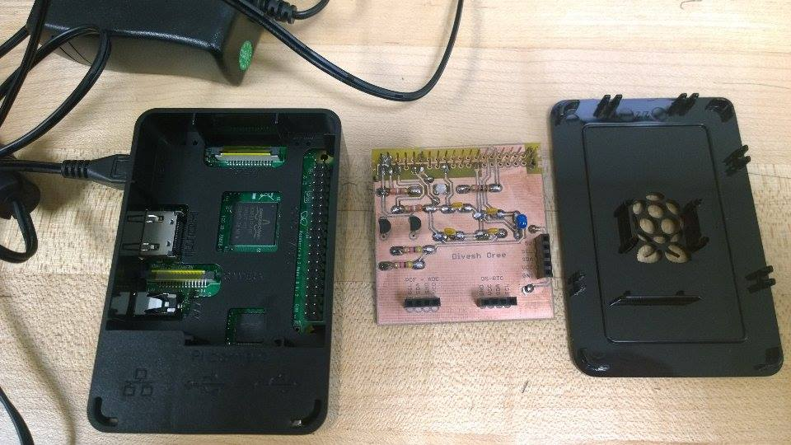

Picture of the previous webcam (Not working):

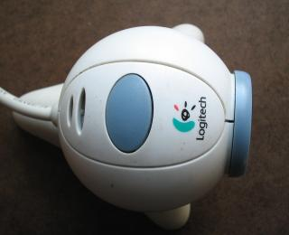

Receipt of the new webcam order (Arrival- 10/14/2016):

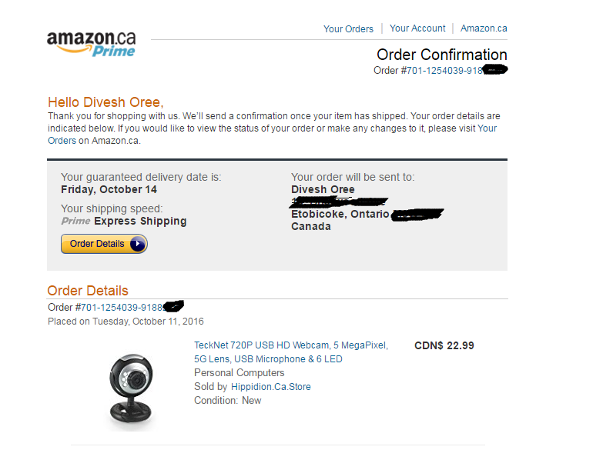

**Next Step:**

My next step will be testing my PCB board and try to get the webcam recognize some barcode strips and see if everything is working properly.